Art/DT/Music- Art Focus  We will be looking at the portraits and sculpture of Pablo Picasso. We will explore techniques for creating our own artwork in pencil, paint and clay.  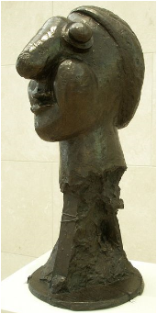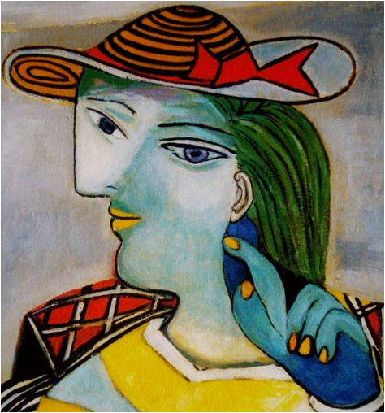 | Science  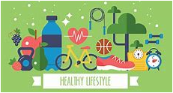  This half term our science continues to be all about us! We will be learning a bit more about our bones, heart, teeth and skin and how to keep them healthy. | Humanities- Geography Focus  During this half term we will be studying the United Kingdom, creating a 3D map and finding out about the countries that make up the UK.  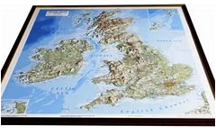
English  Our first text is a beautiful book called ‘Orion and the Dark’. It is all about facing and overcoming our fears. We will be writing our own story, offering advice about how a character can overcome a different fear.  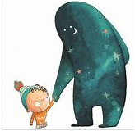  We will then be using our learning from Science and SMSC to write a leaflet about how to keeping healthy and safe. | Class 1 Curriculum Overview  Spring Term 2 2020  Amazing Me!  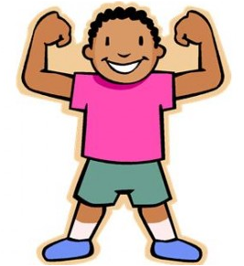  Nurture, Inspire, Achieve | Maths  The focus for the first few weeks is on fractions. For Early Years, this means using the language ‘half’ ‘quarter’ and ‘equal parts’. Year 1 will be finding half and quarter of shapes and small amounts. Year 2 will be exploring halves, quarters and thirds of shapes and amounts and extending to finding three quarters and two thirds.  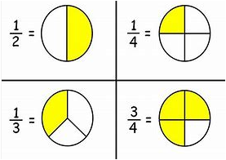
SMSC (Social, Moral, Spiritual and Cultural education)  Our lessons this half term will be all about the Easter story and how Christians celebrate Easter.  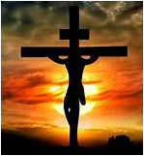  Computing  We will be using our computing skills to present work using word processing and presentation software. | Please talk to your child at home about their learning in school and encourage them to do Home Learning. Do ask if you have any queries about any of your child’s learning.  Many thanks for your ongoing support,  Mrs Luxford. | PE  We are very excited about our Tuesday afternoon swimming lessons this term. Those of us who are not yet swimmers will be developing water confidence and working towards taking our first unaided strokes across the pool. Those of us who are already swimming will be improving our technique and challenging ourselves to swim further than before.  