Art/DT/Music  In music we will have a go at learning some sea shanties, singing rhythmically and as a group.  In our Art lessons we will have a look at the famous sea paintings of the artist Turner. We will explore some techniques and create our own sea paintings inspired by his work.  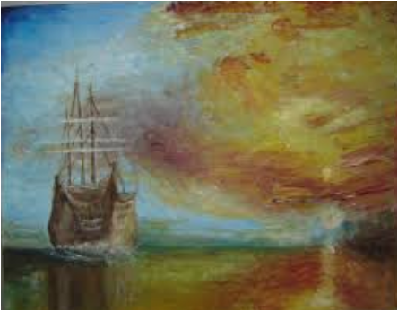 | Science  In science, as well as learning a bit about underwater habitats, and the creatures that make them their home we will be learning about life cycles and talking about the differences between things that are living, dead and have never been alive.  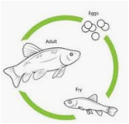 | Humanities  We will be learning about the life of Captain James Cooke and his adventures exploring the oceans and mapping new and undiscovered continents. We will be comparing life in Elizabethan times with our own times including what we know now about how to keep healthy compared with ideas about health in Elizabethan times including how to combat scurvy on long sea voyages! We will also learn the names of the oceans and do some map making of our own.
English  We will be doing some exciting story writing inspired by Mrs Armitage and the Big Wave. We will also look at journal writing based on the adventures of the intrepid sea explorer Captain James Cooke and have a go at writing our own seafaring diaries.  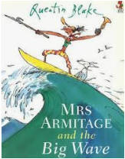  There will be a focus on grammar vocabulary this half term. We will use words: noun, verb, adjective, conjunction, plural to talk about our writing. | Lydford Primary School  KS1 Topic Overview  Summer 1: 2019  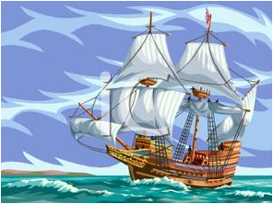  Sea Explorers | Maths  We will be learning about statistics including using tally charts and pictograms to collect and interpret information. At the same time we will be revising and extending our understanding of place value to numbers up to 100. We will then be learning the geometry skills needed to describe position and direction.  The half term will have a focus on deepening our maths understanding using problem solving and investigative activities.  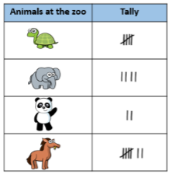  .
PSHE/RE  This half term we will be looking at the meanings of symbols, particularly how food is used as a symbol in religions by thinking about foods that are special to us and why. We will then be comparing the foods eaten by Jewish children on the Sabbath with foods that Christians eat to remind them of Jesus. We will be talking about the significance of bread and trying different sorts of bread. | Please talk to your child at home about their learning in school and encourage them to do Home Learning. Do ask if you have any queries about any of your child’s learning.  Many thanks for your ongoing support, Mrs Luxford. | PE  Hopefully the sun will shine on our PE lessons this half term. We will be doing PE outdoors as much as possible so please make sure your child has kit, including shoes, in school every day. This half term we will be doing parachute games and ball skills in our PE sessions.  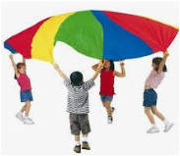

Art/DT/Music  In music we will have a go at learning some sea shanties, singing rhythmically and as a group.  In our Art lessons we will have a look at the famous sea paintings of the artist Turner. We will explore some techniques and create our own sea paintings inspired by his work. | Understanding of the world  We will be collecting and exploring objects related to the seaside. We will be talking about features of the sea and how it varies from other environments in terms of similarities and differences.  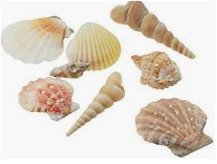 | Humanities  We will be learning about the life of Captain James Cooke and his adventures exploring the oceans and mapping new and undiscovered continents. We will also be talking about past and present events in our own lives and the lives of family members.
Reading and Writing  We will be doing some exciting story writing inspired by Mrs Armitage and the Big Wave. We will also look at journal writing based on the adventures of the intrepid sea explorer Captain James Cooke and have a go at writing our own seafaring diaries.  There will be a focus on using our sounds to write sentences with capital letters, full stops, finger spaces and correctly formed letters. | Lydford Primary School  EYFS Topic Overview  Summer 1: 2019  Sea Explorers | Maths  We will be learning about statistics including using tally charts and pictograms to collect and interpret information. At the same time we will be revising and extending our understanding of numbers to 20, adding and subtracting.  The half term will have a focus on deepening our maths understanding using problem solving and investigative activities.  .
Personal, Social and Emotional Development  This half term we will be looking for ways to play co-operatively, taking turns with others and taking other’s ideas about how to organise activities into account. | Please talk to your child at home about their learning in school and encourage them to do Home Learning. Do ask if you have any queries about any of your child’s learning.  Many thanks for your ongoing support, Mrs Luxford. | Physical Development  Hopefully the sun will shine on our PE lessons this half term. We will be doing PE outdoors as much as possible so please make sure your child has kit, including shoes, in school every day. This half term we will be doing parachute games and ball skills in PE.

